The ClearNav Variometer

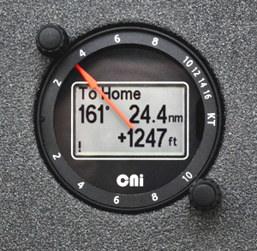 | The ClearNav Variometer is currently in use in AUS and finally (April 1) all the club vario features are available. The competition version linked to CD Display will soon be available.vCheck the news section of ClearNav site updates.  The vario is highly configurable and provides scalable capability from an entry level basic T.E. vario for club use ($US1550) to a fully featured racing vario including Speed-to-Fly, enhanced wind vector calculations, acceleration corrections to T.E., and a secure flight recorder (later & $US700 more)  A more detailed description of the instrument features are detailed at www.clearnav.net I like the home page of 20sec smart averager (top) and “bottom to now” averager (bottom)
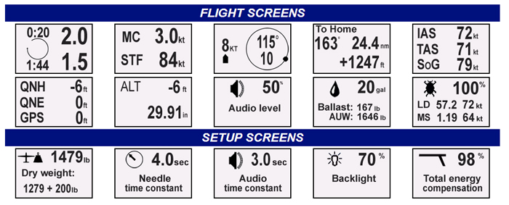

Set up correctly most varios read much the same on those smooth thermal days but it is those broken gusty days when you need a new generation vario. This vario is using much improved gust filtering using the new generation sensors like smart phones. Also the cruise/climb switching is second to none. LX9000 users report when you really need to know (entering thermal) the information presented to pilot is confusing. Most top pilots with LX9000 report using an other audio vario other than LX9000 but ask Brad Edwards, Bruce Taylor, Dave Shorter or Jay Anderson to name a few. Congratulations to Terry Ryan on completing 1000km within 3 weeks of installing his new CNvario and MFD in December 2012.
  - GREAT NEW GENERATION SENSORS(inc improved gust filtering)
  - three-axis accelerometer
  - two axis rate sensor
  - three-axis magnetometer
  - five Hertz (fast) GPS receiver.
  - Club Version $US1550 & XC Version $US2250 (club upgrade $700)
- ADC and display software field-upgradeable.
- High-visibility mechanical pointer driven from edge of meter by a stepper motor, a back lit dot matrix LCD and two rotary encoders for control.
- Fully compatible with ClearNav MFD.
- The display module also acts as a repeater for two-seat installations.
- 57 MM (mini) display size fits any panel.
- T.E. available either from a suction probe or using pitot and static.
- In-flight fine tuning of T.E. suction compensation.
- ADC is highly configurable and provides scalable capability from an entry level basic T.E. vario for club use to a fully featured racing vario including Speed-to-Fly, enhanced wind vector calculations, acceleration corrections to T.E., and a secure flight recorder.
- Display module also highly configurable with in-flight user control of:
  - Time constants (LCD, pointer and audio)
  - Displayed parameters (Netto, T.E., relative netto, smart averager, bottom-to-now climb etc)
  - Bugs,ballast, MC, volume
  - Profiles (set up profiles on the ground, instantly select one in flight)
Additional features include:
- Configurable manual cruise climb switch (automatic March 2013)
- Automatic volume control with ASI
Future Developments
The first goal was to bring the CN Vario to market as quickly as possible which has now happened. Next CN are working on advanced gust filtering based in part on pitch rate measurements. Then CN are also working on enhanced wind vector measurements which do not require the pilot either to change direction or to circle. These will come reasonably soon (guess mid year) including linking to CN MFD and full Navigation feature and finally secure logger which IGC must certify by 3rd quarter of 2013.
Ian McPhee, Box 657, Byron Bay, NSW 2481. mrsoaring@gmail.com 0428847642

